Ayan Sarkar

University of denver

ABCD ISP Version 2.3 SERVICES performance report

**Executive Summary**:

This business report states the findings of the feedback received for ABCD’s newly launched, ISP V 2.3 services.

The findings from the feedback is represented across six categories related to the product, namely: General Satisfaction, Pricing and Billing, Product Performance, Product Functionality, Product Characteristics & Customer Service. General Satisfaction has received the highest approval and Product Functionality has received the least approval from the customer base.

The general satisfaction of the product is overall positive at 84.97%. Few of the notable reasons for general dissatisfaction of the service are its advertisements and the instructions providing for using the services. Our recommendation would be to further fine tune the advertisements as per the personal likes and dislikes of the user and provide better user-friendly service instructions to the customers.

When it comes to the pricing and billing of the service, the overall sentiment is positive at 58.9%. The discontent observed in this sector is due to the fact that some customers do not find the pricing of the service to be of reasonable budget. Our recommendation would be to bring out diversified plans for the service which would be suitable for customers for a variety of purchasing power.

Product performance has been accepted by customers in a favorable light with a positive response at 62.38%. The customers have the most mixed opinions on the usability and reliability of the product. We recommend that further detailed surveys be done on these areas to understand the aspects in these areas which are acceptable and not acceptable to the consumers.

Customers are happy with the product functionality as well, with an approval rating of 58.13%. Consumers are the happiest with the feature designs of the service. The major source of discomfort for the consumers, regarding the functionality is pop-ups encountered during surfing. We recommend providing the users with pop-up blocking options to the users.

Product characteristics has managed to impress customers the most, with an approval rating of 72.46%. Customers are happiest with the comfort and variety of the service. The one subject with mixed opinions in this area are various size offerings of the service. We recommend that detailed surveys be done among the customers to find out their preferable size(bandwidth) of the services to be provided.

Lastly, the customer service provided for this service has received mixed feelings from the consumers. We recommend an internal audit been done for the customer service unit to better understand the customer grievances and adapt accordingly to provide elegant solutions to their problems about the service.

Note: For statistics and graphical representations of the above findings, please refer the**Section 3** of Appendix.

**Approach to Analysis**:

SPSS was the primary tool used for the word extraction, category analysis, and sentiment analysis on the reviews collected for the ABCD’s newly launched IPS services.

The analysis revolves around 6 main categories pertaining to the service provided by ABCD: General Satisfaction, Pricing and Billing, Product Performance, Product Functionality, Product Characteristics & Customer service provided by ABCD for the product. For details regarding the categorization process, please refer to Section 1 in the Appendix.

The analysis is based on 9003 reviews by the ABCD customers; all these reviews were categorized under the above six categories to derive the overall sentiment regarding these areas, to guide the management regarding the performance of the newly launched IPS services.

The sentiment of the customers regarding these six categories was categorized as positive or negative as per the contents of the reviews. Once all the reviews under a category were flagged with their respective sentiments, the percentage of positive and negative sentiments were computed to judge the over all opinion of the customer regarding the category in question.

Once the overall sentiment of the categories were computed; further drill down was done for each of the categories into the constitution of the Positive and the Negative sentiment computed for the categories; this was done with the thought process that additional drill down in the break down of the sentiments, would need to be investigated by ABCD to address the customer concerns to further improve their services in the future. For details regarding the segregation of the sentiments of the reviews, please refer to Section 2 in the Appendix.

**Appendix**:

1. **Section 1**: Categorization process

The Text Mining node was used in SPSS to form the categories from the 9003 reviews. The interactive bench was selected for building the categories using the “Exploring Text Link analysis results” approach, opting for the “Product Satisfaction (English)” as the Text analysis package to create categories, considering the sentiments in the reviews grouped into them.

After getting the initial categories generated by the Text mining node, the “Build” option was used to further produce categories from the Uncategorized reviews; the categories under this option was built from the “Type patterns” in the reviews. The advanced settings used for the “Build” options were:

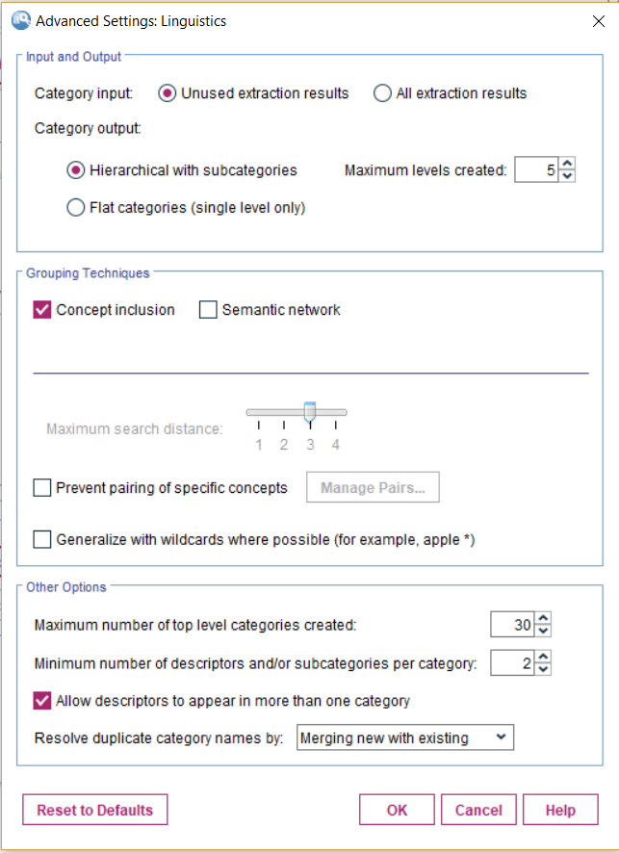

Fig 1: Advanced setting for building categories

After getting the set of categories after the build operations, I concentrated all the categories under these final 6 categories; with each category having its positive and negative separate categories. These grouping were done with the help of rules and movement of smaller categories into their parent groups.

Please find the final set of categories in the next page along with their document scores. After the final round of categorization, the number of uncategorized reviews accounted to 12% of the whole data.

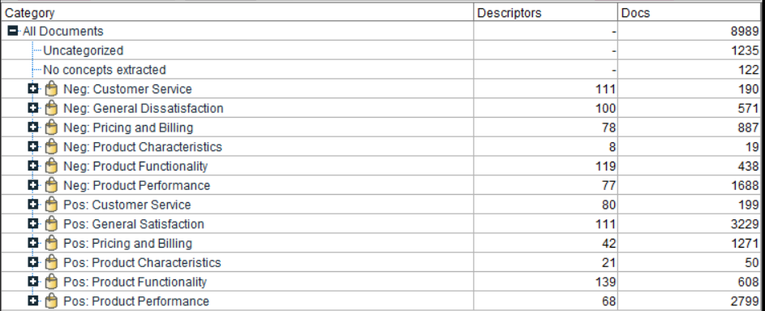

Fig 2: Final list of created categories

Please find below a sample example of rules involved in construction of the categories:

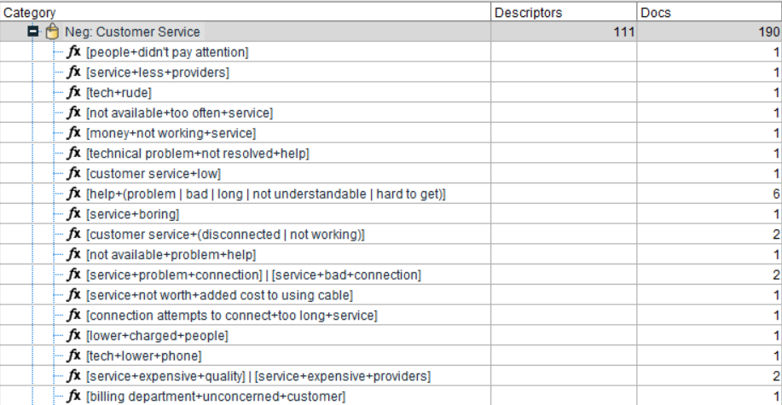

Fig 3: Rules in a category

Please find below an example of a review under “Neg: Customer Service”:

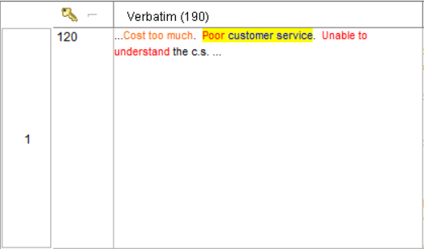

Fig 4: Example of a review under “Neg: Customer Service”

1. **Section 2:** Segregation of Sentiments of the reviews in SPSS

To generate the segregation of the positive and negative sentiment of a category, the following settings for the model nugget was used:

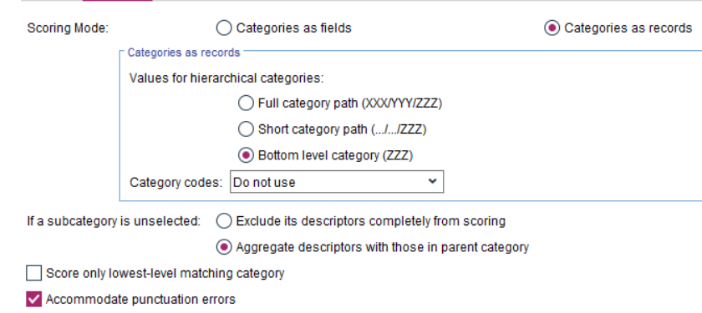

Fig 5: Settings for model nugget – 1

These settings give the below format of data:



Fig 6: Data from model nugget – 1

After the generation of data, “Select” nodes were used to isolate each category in 6 flows to generate their individual visualizations.

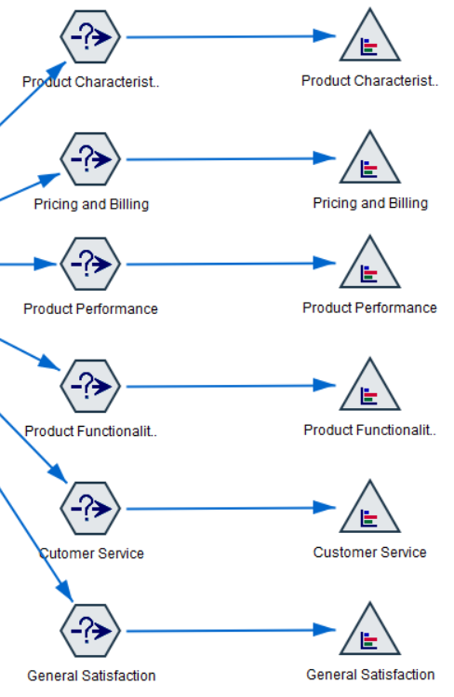

Fig 7: Design flow in SPSS for Visualizing sentiments from each category

Please find below a sample expression used in the “Select” node in the above work flow:

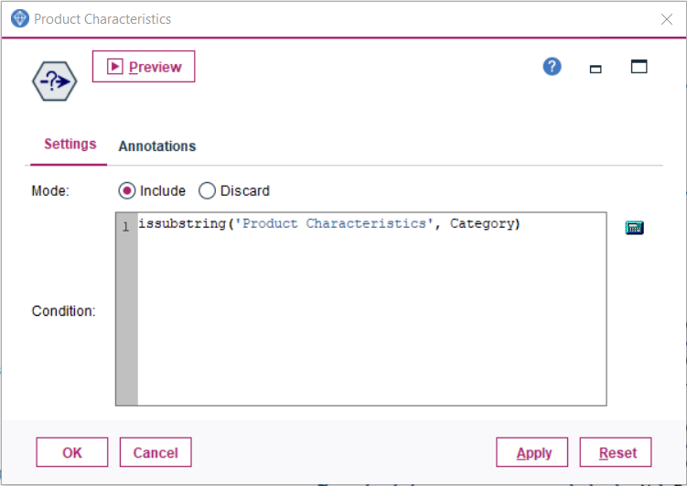

Fig 8: Sample expression used in the “Select” node

Please find below the settings used in the “Graph Distribution” node in the above work flow:

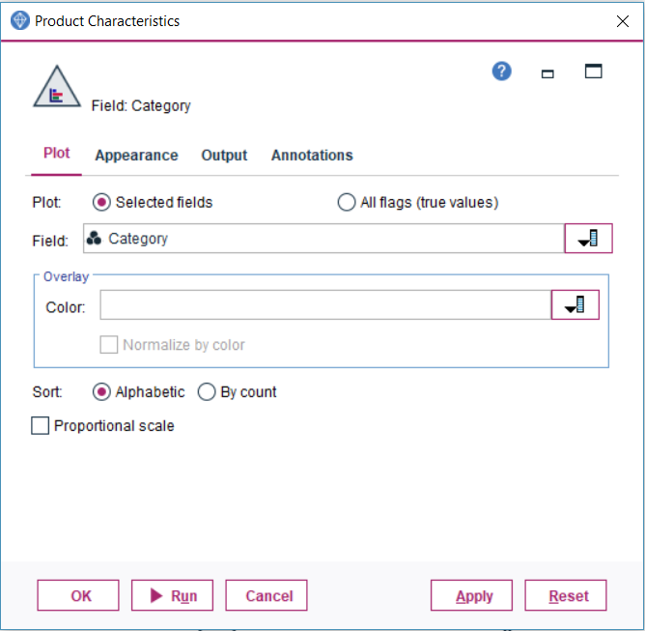

Fig 9: Settings used in the “Graph Distribution” node

To generate the breakdown of the categories within the positive and negative sentiment categories for the six main categories, the following settings for the model nugget were used:

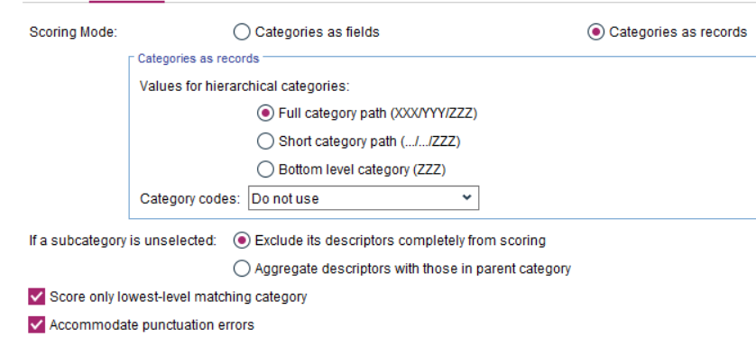

Fig 10: Settings for model nugget – 2

These settings give the below format of data:

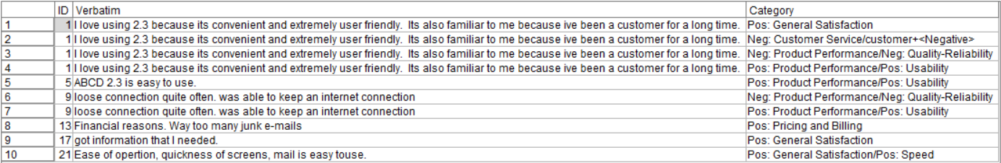

Fig 11: Data from model nugget – 2

After the generation of data, “Select” nodes were used to isolate each category in 12 flows to generate their individual visualizations for their positive and negative counterparts.

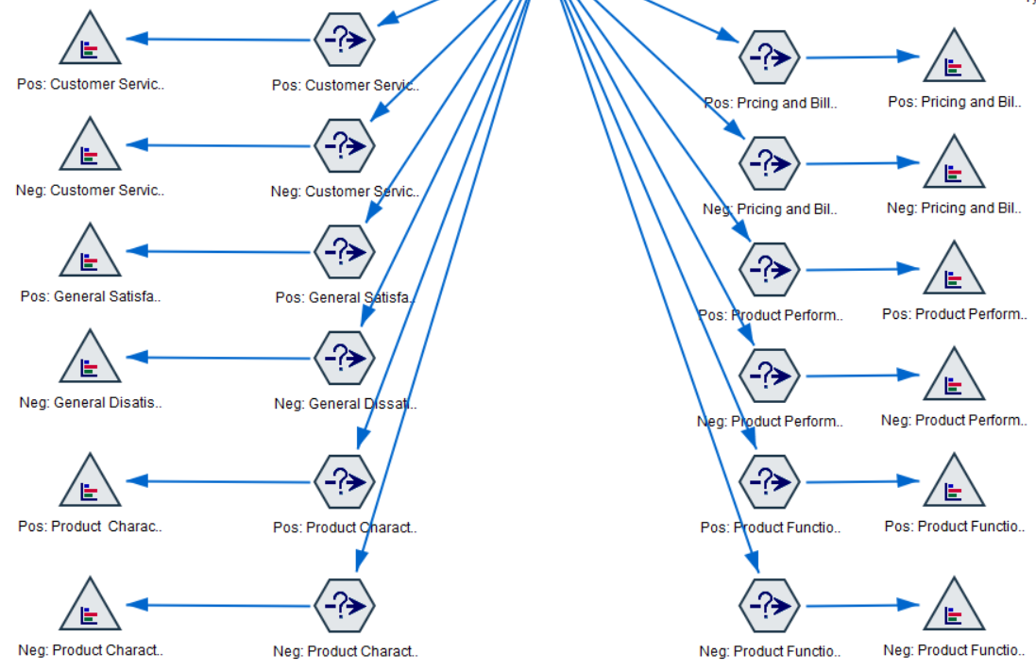

Fig 12: Design flow in SPSS for Visualizing positive & negative sentiments from each category

Please find below a sample expression used in the “Select” node in the above work flow:

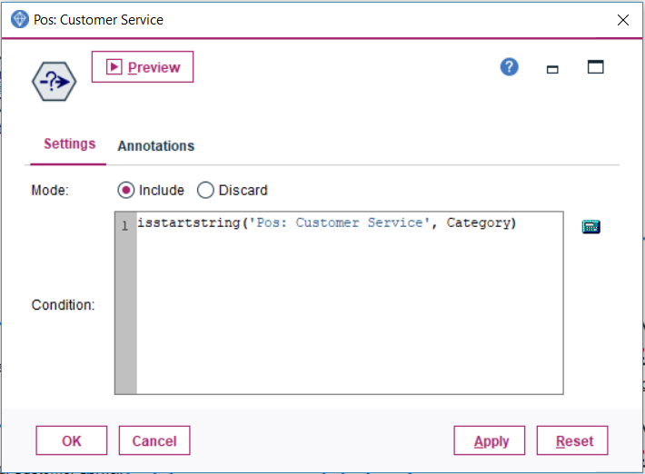

Fig 13: Sample expression used in the “Select” node

Please find below the settings used in the “Graph Distribution” node in the above work flow:



Fig 14: Settings used in the “Graph Distribution” node

1. **Section 3**: Visualizations of the findings from sentiment reviews in SPSS

Pricing and Billing:

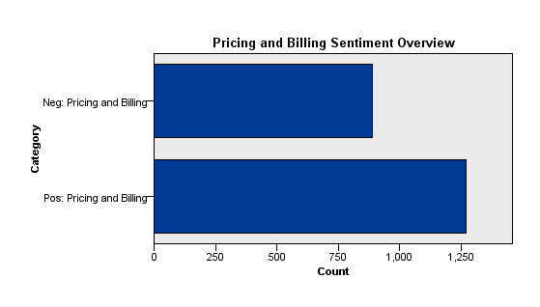

Fig 15: Pricing and Billing Sentiment Overview

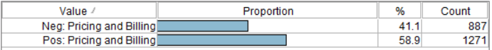

Fig 16: Data for Pricing and Billing Sentiment Overview

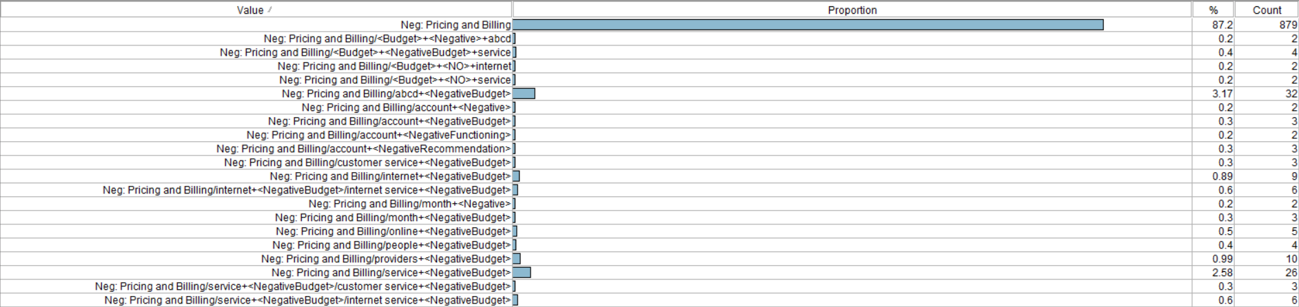

Fig 17: Break down for Pricing and Billing Negative Sentiment Category

Product Performance:

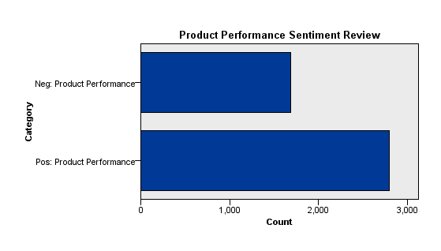

Fig 18: Product Performance Sentiment Overview

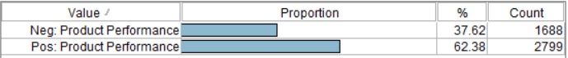

Fig 19: Data for Product Performance Sentiment Overview

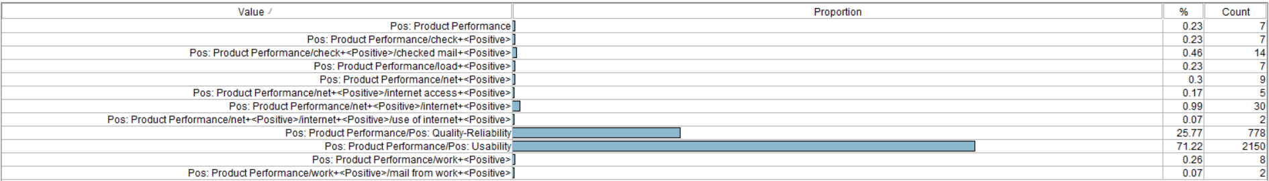

Fig 20: Break down for Product Performance Positive Sentiment Category

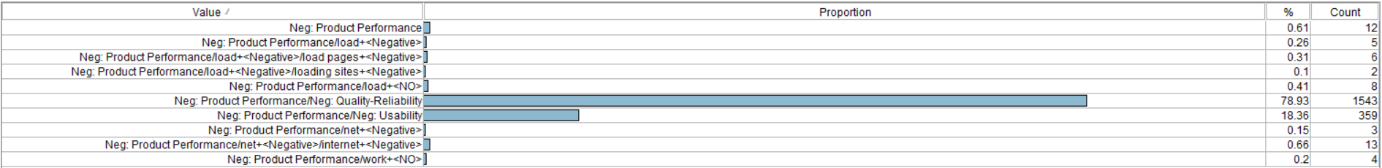

Fig 21: Break down for Product Performance Negative Sentiment Category

Product Functionality:

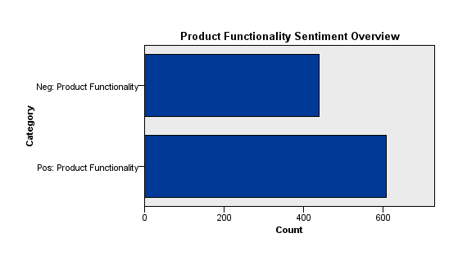

Fig 22: Product Functionality Sentiment Overview

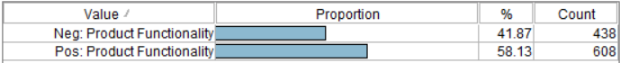

Fig 23: Data for Product Functionality Sentiment Overview

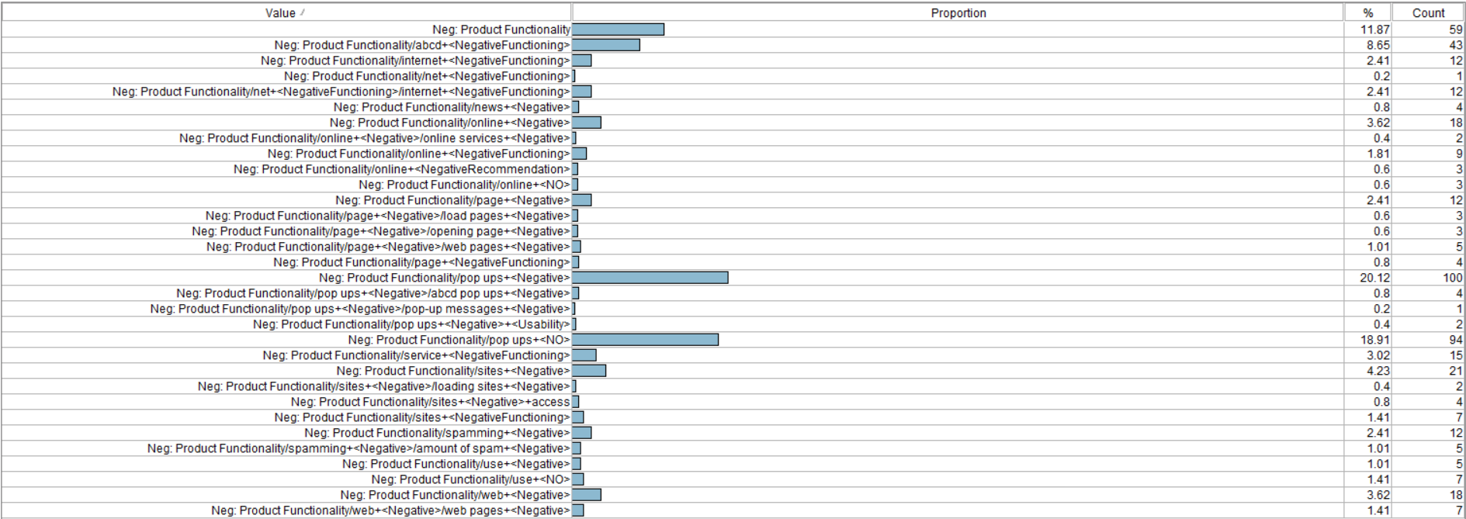

Fig 24: Break down for Product Functionality Negative Sentiment Category

Customer Service:

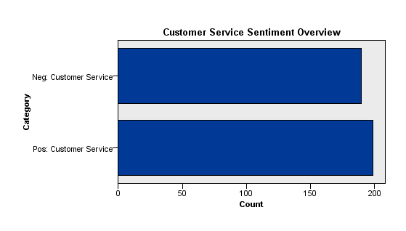

Fig 25: Customer Service Sentiment Overview

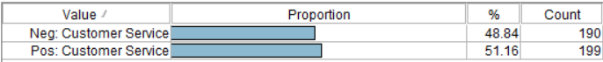

Fig 26: Data for Customer Service Sentiment Overview

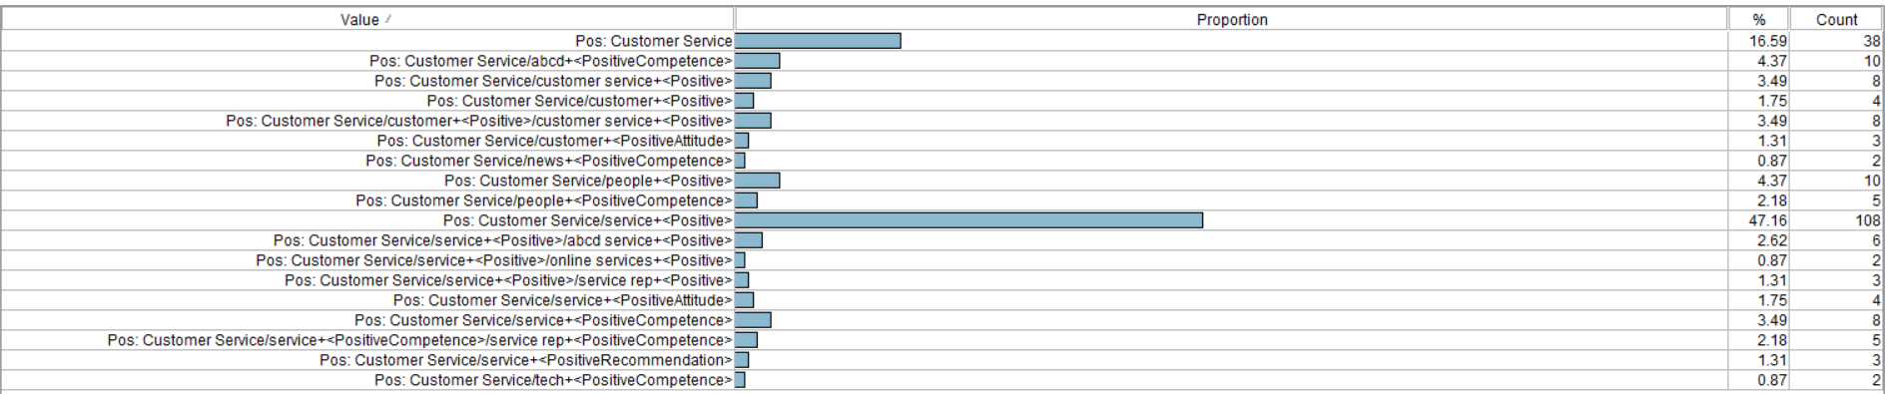

Fig 27: Break down for Customer Service Positive Sentiment Category

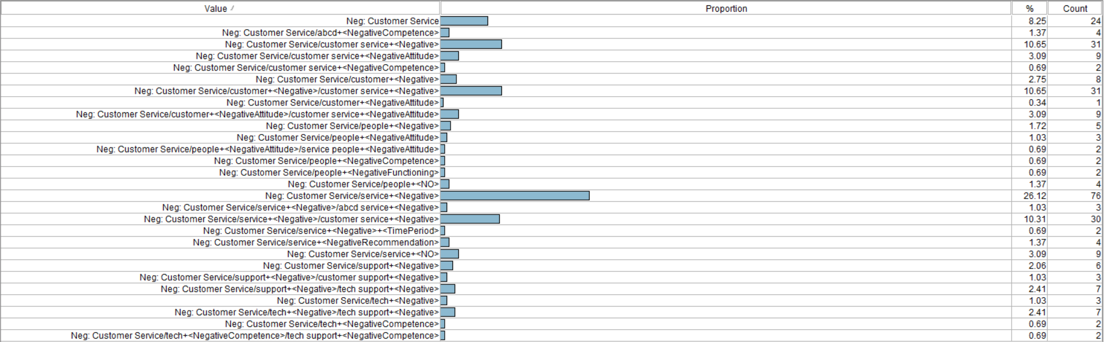

Fig 28: Break down for Customer Service Negative Sentiment Category

General Satisfaction:

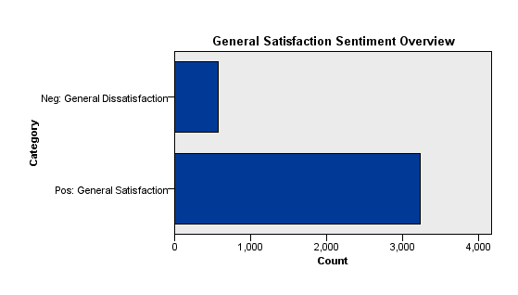

Fig 29: General Satisfaction Sentiment Overview

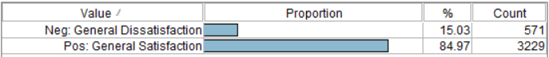

Fig 30: Data for General Satisfaction Sentiment Overview

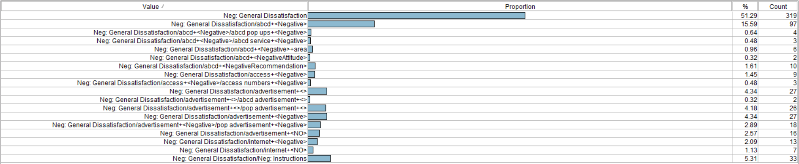

Fig 31: Break down for General Satisfaction Negative Sentiment Category

Product Characteristics:

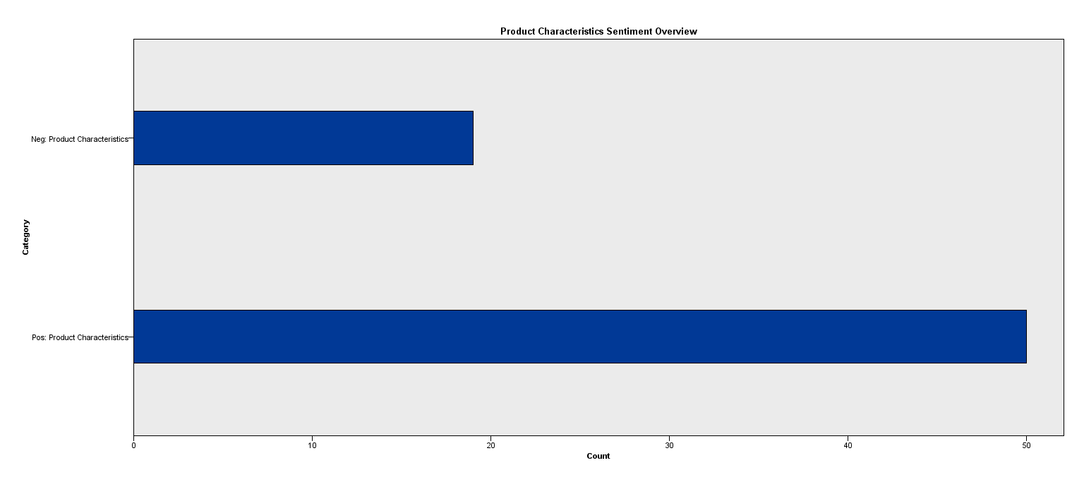

Fig 32: Product Characteristics Sentiment Overview



Fig 33: Data for Product Characteristics Sentiment Overview



Fig 34: Break down for Product Characteristics Positive Sentiment Category



Fig 35: Break down for Product Characteristics Negative Sentiment Category